**2018 Season Sponsorship Package**

Thank you for your interest in sponsoring the Beet City Bombers roller derby team. We are currently seeking support from local businesses and community members in order to continue our community involvement programs and fund our 2018 season. We are confident that your partnership with BCB will provide your business with valuable exposure to previously untapped demographics, and the opportunity to be a part of one of the fastest growing sports in the world.

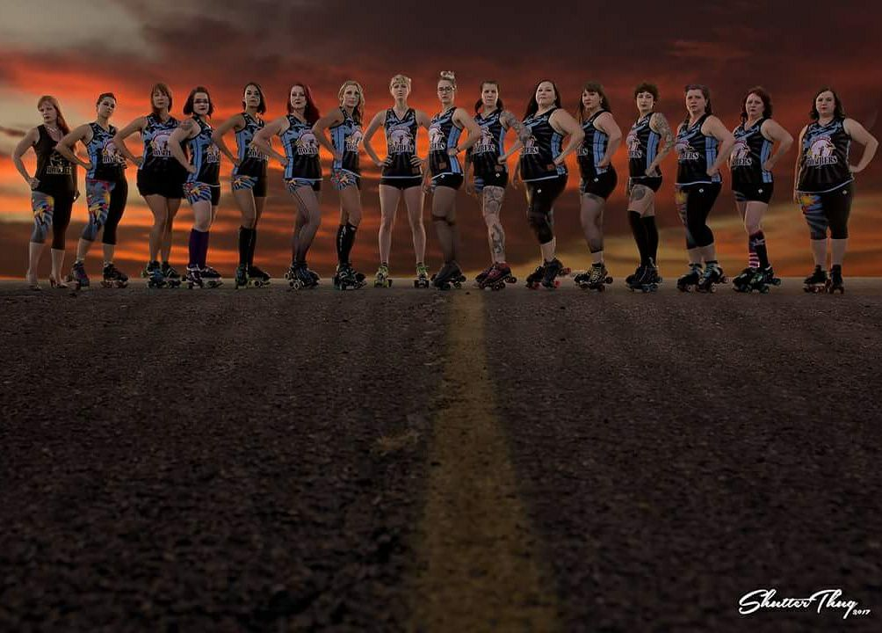

**Who Are We?**

The Beet City Bombers (BCB) are a nonprofit organization organized​ ​for​ ​the​ ​purposes​ ​of​ ​promoting​ ​women’s empowerment,​ ​health,​ ​exercise,​ ​and​ ​strength​ ​through​ ​involvement​ ​in​ ​the​ ​sport​ ​of​ ​roller​ ​derby. BCB​ ​is​ ​committed​ ​to​ ​developing​ ​amateur​ ​athletes​ ​for​ ​competition,​ ​and​ ​promoting​ ​the​ ​physical and​ ​mental​ ​strength​ ​of​ ​female​ ​athletes​ ​while​ ​fostering​ ​and​ ​cultivating​ ​social​ ​camaraderie​ ​among members. Our team currently boasts an age range between 21 and 58. Derby knows no shapes, size, age, color, or occupation. We love having ladies from all walks of life, working, learning and thriving together.

**Support Your Local Women!**

Roller derby is a real sport, with real contact. Unlike roller derby of the 1970s, today’s roller derby is not a theatrical performance. Roller derby today is a turn showing of strong, athletic women battling it out on the flat track. BCB follows the rules set forth by WFTDA (Women’s Flat Track Derby Association), the sport’s international governing body. In addition to training several times a week for a couple of hours at a time, BCB actively participates in the local community. We can be seen at 4th Friday in downtown Nampa, the annual Parade America, the annual Wyakin Foundation fundraiser, and much more!

**Roller Derby Outreach and Popularity**

Roller derby is a fast growing, highly visible, and full contact sport. There are currently over 1,200 roller derby leagues in the United States, and more worldwide. Roller derby is attracting more fans than ever before. Our fans and followers feel very passionate about flat track roller derby and defy all stereotypes. From sports fans, to punk rockers, to soccer moms, and children, our advertising reaches them all. Advertising with us gives you the opportunity to reach hundreds of local fans from all walks of life.

**Practice and Game Location**

BCB does travel each season to compete against other teams in the Pacific Northwest. Our home games are held in Caldwell at the O’Connor Fieldhouse. Practices are held at the Nampa Rollerdrome. All of our events are family friendly and provide something for every age group.

Want to learn how you can donate to BCB, or sponsor our awesome league? Please email our Treasurer and Sponsorship Extraordinaire @ 77.dirty.dani@gmail.com

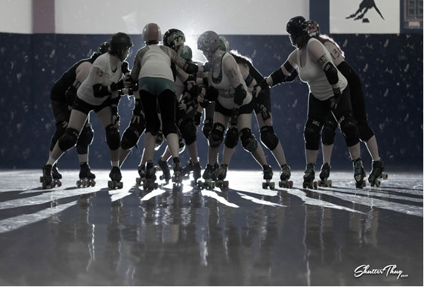

**Sponsorship Levels**

|  |  |  |  |  |  |
| --- | --- | --- | --- | --- | --- |
| **Sponsorship packages** | **Titanium** | **Platinum** | **Gold** | **Silver** | **Bronze** |
| **# of season passes** | 4 | 4 | 2 | 2 | 1 |
| **Program Ad** | Full page | ½ page | ½ page | ¼ page |  |
| **BCB T-shirt** | 4 | 2 | 2 | 2 | 1 |
| **Banner Placement** | Yes | Yes | Yes |  |  |
| **Logo on Webpage** | Yes | Yes | Yes | Yes | Yes |
| **Special Thanks during home bouts** | Yes | Yes | Yes |  |  |
| **Cost Per Season** | $1000 | $700 | $500 | $300 | $200 |

**Penalty Box Sponsor**

The penalty box is named after your business (you choose the name); each time a skater enters the penalty box, your business is announced. For example, ‘Skater # now entering the Java Box sponsored by XXX Coffee shop’

Penalty Box $500 for the season or $150 per individual bout.

Sponsorship is prominently displayed on our Facebook Page.

Logo link to sponsor’s website on [www.beetcitybombers.com](http://www.beetcitybombers.com)

Sponsorship is announced before and during the bout.

You may provide a banner to be displayed at the bout you choose to sponsor.

Two tickets provided per bout sponsored, unless a season sponsorship is purchased, then receive two season passes.

**Jam Line Sponsor**

The penalty box is named after your business (you choose the name); each time a skater enters the penalty box, your business is announced. For example, ‘Skaters now lining up at the Diamond Line sponsored by XXX jewelers’.

Jam Line Sponsor $500 for the season or $150 per individual bout.

Sponsorship is prominently displayed on our Facebook Page.

Logo link to sponsor’s website on www.beetcitybombers.com

Sponsorship is announced before and during the bout.

You may provide a banner to be displayed at the bout you choose to sponsor.

Two tickets provided per bout sponsored, unless a season sponsorship is purchased, then receive two season passes.

**Medical Sponsors**

Want to provide us with medical services such as acupuncture, chiropractic, massage, personal training? Or have another idea that could fall under the medical umbrella? Let us know!

**We love our medical sponsors! You keep us rolling!**

Season medical sponsors benefits are:

Sponsorship is prominently displayed on our Facebook Page.

Logo link to sponsor’s website on www.beetcitybombers.com

Sponsorship is announced before and during the bout.

You may provide a banner to be displayed at each home bout of the season.

Two season passes.

A BCB t-shirt.

BCB is nonprofit; please speak with our Treasurer for a receipt of services if needed at [77.dirty.dani@gmail.com](mailto:77.dirty.dani@gmail.com).

**A’la Carte Advertising (Per Event)**

**Program Ads:**

Full page $100

½ Page $75

¼ Page $50

Banner Placement $50

Logo and Web Link $25

**Questions about sponsorship? Please email our Treasurer and Sponsorship Extraordinaire @ 77.dirty.dani@gmail.com**

**All BCB Skaters PAY TO PLAY**

What does this mean? All players fund their own roller derby journey. We pay monthly dues to practice, purchase our own uniforms, pay for travel, and fund our bouts and after parties. This year the BCB ladies will be purchasing new white and dark jerseys, as well as play in five away bouts across the PNW. Have you ever heard of Roller Con? This is a weeklong derby convention in Las Vegas, which many team members will attend, in addition to other skate clinics throughout the country, such as Camp Elite in Eugene, OR. Our ladies are dedicated to learning all they can and working hard to give you roller derby in Canyon County.

*Help in any of these areas allows derby love to grow day by day.*

**INTERESTED IN SPONSORING ANY OF THE ABOVE?**

Travel costs for away bouts! Clinics! Roller Con! Jersey Costs! Individual skater dues!

Please email our Treasurer and Sponsorship Extraordinaire @ [77.dirty.dani@gmail.com](mailto:77.dirty.dani@gmail.com).

**We can hook you up!**

*Donations are always kindly accepted.*

**Not Seeing What You’re Looking For?**

We are open to negotiation on individual business sponsorships. Have an event you would like us to work? Maybe you would prefer an in-kind sponsorship, such as an exchange of advertisements. Do you offer a service you would like to provide our team? Or perhaps you would like to set up a booth at a bout for some front line exposure? All of these are possibilities!

Please email our Treasurer and Sponsorship Extraordinaire @ [77.dirty.dani@gmail.com](mailto:77.dirty.dani@gmail.com).

***We are happy to work with you to find the sponsorship of your dreams*.**

**We are actively looking for:**

*A printing sponsorship*

*An after party catering sponsorship*

*A team trainer*

*Medical staff for bouts*

**BCB is proudly nonprofit. We love sponsorships! Donations are also kindly accepted. Thank you for supporting your local roller derby!**

**Black and Blue Ball**

The Beet City Bombers are happy to announce this year they will be hosting their first annual Black and Blue Ball, set to be held at the end of the season, in early December. The Black and Blue Ball will be a formal black tie community affair with open invitations extended to everyone who loves and supports roller derby, and yes, this certainly includes our sponsors! There will be music, food, dancing, a silent auction, and overall a wonderful time. Our goal is to fund our 2019 season, and you can help turn our hope into a reality at this swinging event! Imagine the marketing opportunities still waiting for you at the end of the year—you know you want to partner with us!

There are so many ways you can partner with us for this event: catering, venue, linens, lights, DJ, etc.—the list goes on. **What can YOU bring to the party?**



For all inquiries about the **Black and Blue Ball**, and how to sponsor or support this event please e-mail our Treasurer and Sponsorship Extraordinaire at 77.dirty.dani@gmail.com

**2018 Sponsorship Agreement**

Company Name________________________________________________________________________________

Contact Name__________________________________________________________________________________

Address_______________________________________________________________________________________

City, State, Zip_________________________________________________________________________________

Phone Number_________________________________________________________________________________

**Sponsorship** **Level**

**IN-KIND Contribution**

Donations, Trades, and In-Kind Contributions are always accepted and appreciated. Let us know if you have any ideas. We would LOVE to work with you!

**Donation amount $____________**

_____ Titanium $1000

_____ Platinum $700

_____ Gold $300

_____ Silver $300

_____ Bronze $200

**Detailed Description:**

_______________________________________________________________________________________________________________________________________________________________________________________________________________________________________________________________________________________

**Al la Carte Advertisement- For one game**

_____ Full Page $100 _____ Banner $50

_____ ½ page $75 _____ ¼ page $50 _____ Web link $25

**Vendor Space at Games**

BCB can provide a vendor space to companies wishing to sell their items at a game. Items must be family friendly. Compliance with our venue contract requires that outside vendors do not market food or beverages. Approval of vendors is voted upon the BCB Board of Directors.

_____ Single Bout Day $30 _____ Full Season (4 bouts) $80

**Medical Sponsors (We so appreciate you!)**

Description of services for 2018 season: _______________________________________________________________________________________________________________________________________________________________________________________________________________________________________________________________________________________

**I agree to the terms of the sponsorship agreement and have enclosed payment.**

**Signature________________________________________________ Date____________________**

**Printed Name_____________________________________________**

Thank you for supporting the Beet City Bombers roller derby team!!! Your contribution is greatly appreciated and allows us to continue to advance the unique women’s sport. Roller derby builds strong women, self-confidence, teamwork, a sense of belonging and community involvement.